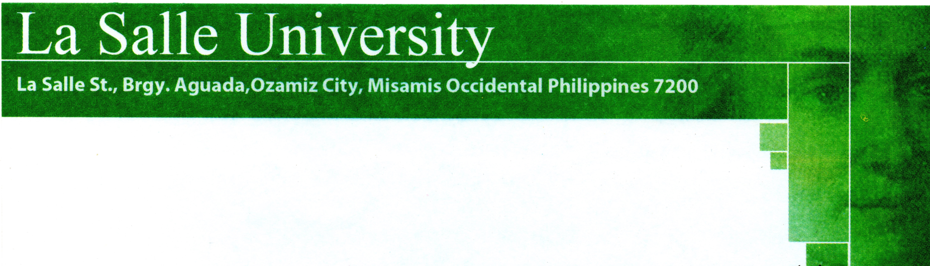

**APPENDIX A**

**TRANSMITTAL LETTER**

December 2017

Project Blood Seeker (web-based blood banking system)

Ozamiz City

Dear Maam Jean Paz Eribal,

We are fourth year Information Technology students of the College of Computer Studies, La Salle University who are currently enrolled in Capstone 1 subject.

In partial fulfillment of the course, we are required to choose a client for our proposed Web Based System. We propose that Philippine Red Cross Ozamiz City Chapter to be our partner of the research.

In connection to this, we would like to ask permission to conduct our study to the mentioned place for the development of our proposed system.

Your response and applauding action on this matter will be highly appreciated. Thank you so much.

Respectfully yours,

Bonnie Jefferson Padilla Aljanly Tayone Christian Rey Paler

Noted: Approved by:

Erbeth Gerald Delvo Jean Paz Eribal

Adviser Administrator

**Website: www.lsu.edu.ph**

**Telefax: (088) 521- 1010**